# Hour of Code – where is the International Space Station?

In this activity you will create a webpage that displays where the ISS is on a map of the Earth. The activity demonstrates how easy it is to build and host a serverless web page on the Microsoft Azure Cloud Platform. If there is time you will also write some javascript to let your page display which astronauts are on the ISS.

In the activity you wll log into an Azure tenant, create a storage account, create a storage blob, set it as a static website, write a webpage and upload it to Azure. Finally you will browse to the page to confirm that everything is working.

## Log in to a storage account.

To log in to a general-purpose v2 storage account in the Azure portal, follow these steps:

1. Open the [Azure portal](https://portal.azure.com/) in your web browser. Use the username you’ve been given (userX@nickparlowhotmail.onmicrosoft.com) and the password “FujitsuHoC1.”.
2. In the Azure portal, select **All services**. In the list of resources, type **Storage Accounts**. As you begin typing, the list filters based on your input. Select **Storage Accounts**.

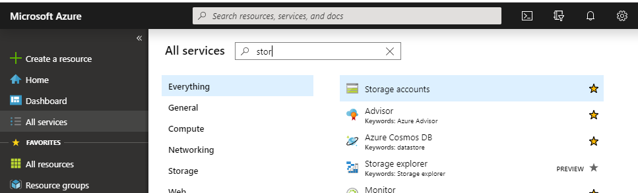

1. On the **Storage Accounts** window that appears, locate the storage account that corresponds to your username – User10 would select user10fujitsuhoc.

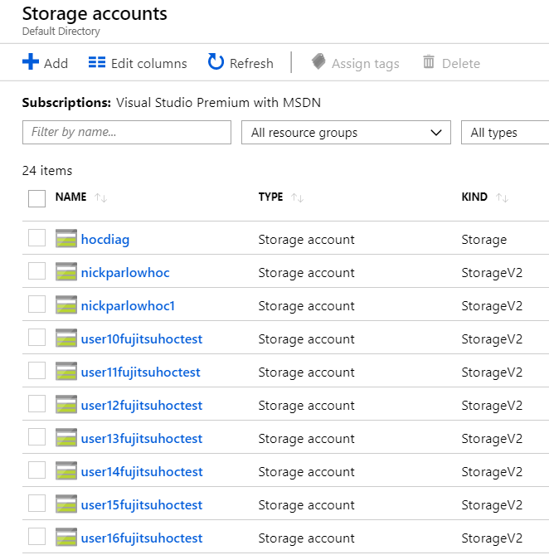

1. Click on the storage account name.

For more information about types of storage accounts and other storage account settings, see [Azure storage account overview](https://docs.microsoft.com/azure/storage/common/storage-account-overview). For more information on resource groups, see [Azure Resource Manager overview](https://docs.microsoft.com/azure/azure-resource-manager/resource-group-overview).

## Configure static websites

1. Select **Static website** to display the configuration page for static websites. You’ll need to scroll down a bit under your storage account name:

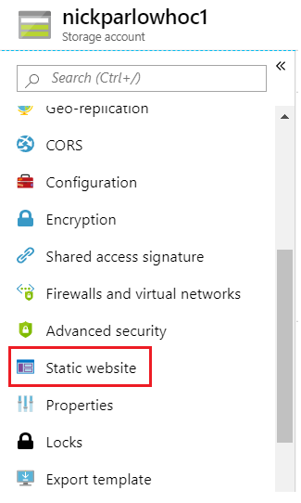

1. Select **Enabled** to enable static website hosting for the storage account.
2. In the **Index document name** field, specify a default index page of *index.html*. The default index page is displayed when a user navigates to the root of your static website.
3. In the **Error document path** field, specify a default error page of *404.html*. The default error page is displayed when a user attempts to navigate to a page that does not exist in your static website.
4. Click **Save**.

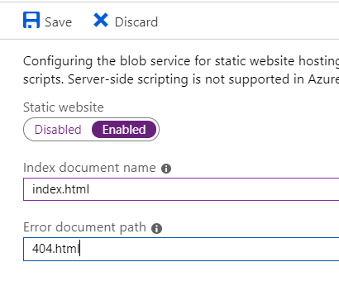

1. The Azure portal now displays your static website endpoint. Copy and paste the endpoint address to a notepad file. You’ll need it in a bit.

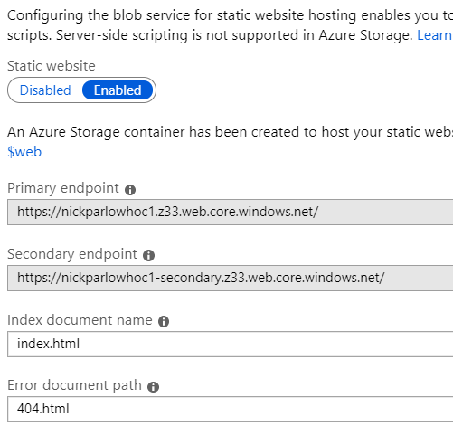

1. Click on “$web” to open the storage location for your static website.

## Create a web page in notepad

1. Open notepad.exe by typing notepad in the search bar in windows.
2. Type the following:

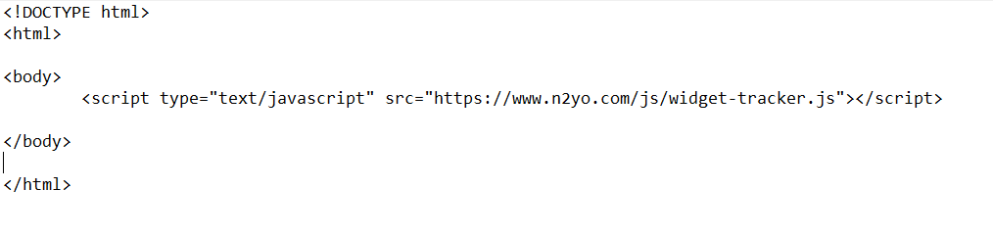

Here it is as text, if you want to copy and paste:

<!DOCTYPE html>

<html>

<body>

<script type="text/javascript" src="https://www.n2yo.com/js/widget-tracker.js"></script>

</body>

</html>

1. Save as “index.html” in a new folder in your documents location. Be sure to choose “save as type: all files” so that it has the correct extension:

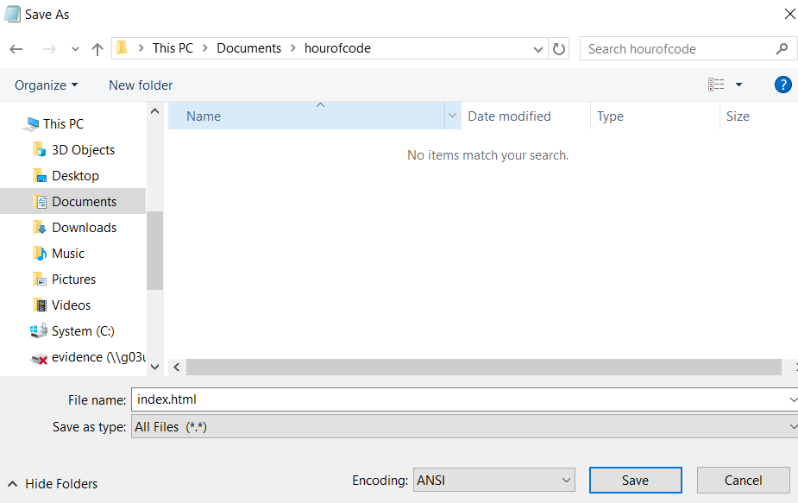

1. Open the file in your browser to make sure it works. Right click the file in windows explorer and select your favourite browser.

## Upload your index file

1. Go back to the azure portal, and click on “upload”

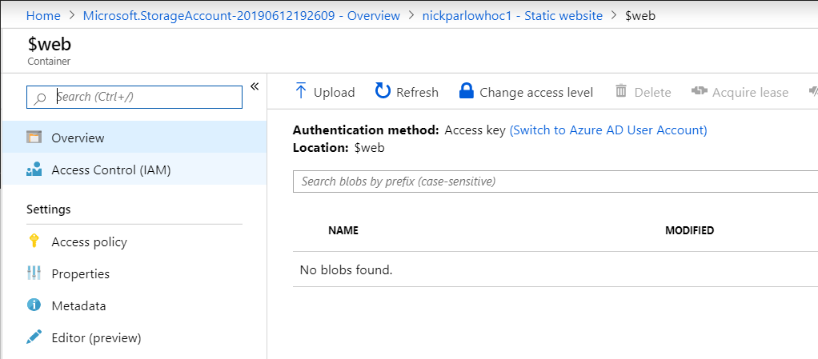

1. Select the file you just created:

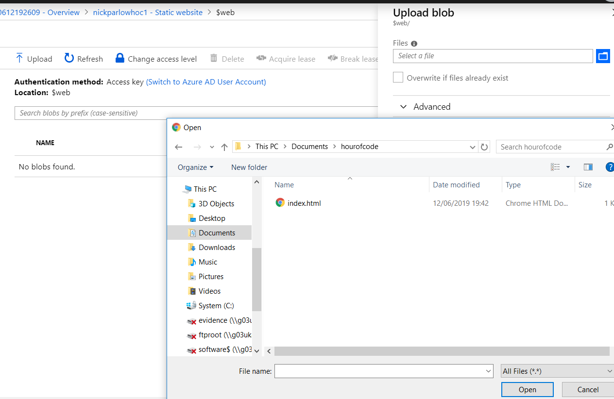

1. Click upload:

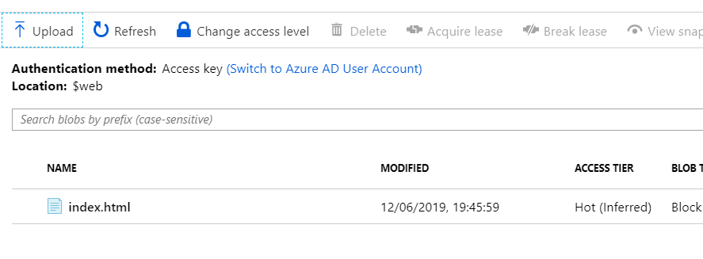

1. In a new browser window, open the endpoint you saved earlier:

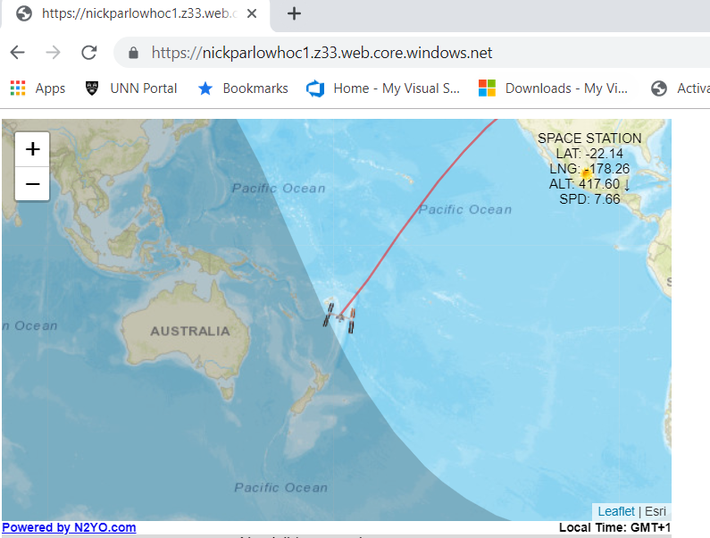

1. Congratulate yourself.

## If you still have time… …fun with APIs

API stands for Application Programming Interface – they are a way for applications to talk to each other over the internet. This activity builds a basic application that displays the astronauts currently on the International Space Station in javascript. For this to work you will need to change re security settings on the storage account.

1. Click on your storage account, select configuration, and disable the “secure transfer required” setting:

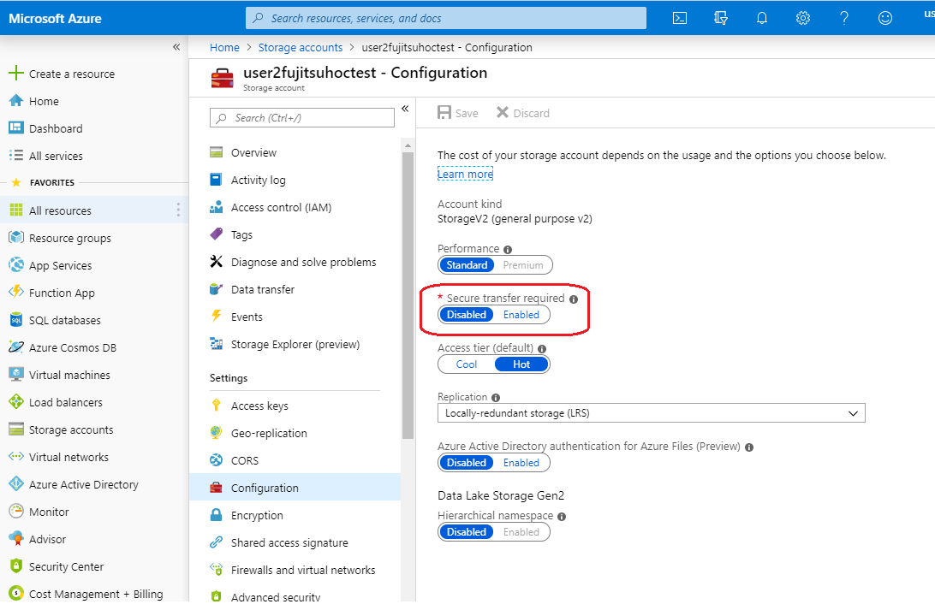

1. Open the index.html file you created earlier in notepad
2. Remove the line <script type="text/javascript" src="https://www.n2yo.com/js/widget-tracker.js"></script>
3. Add a script tag:

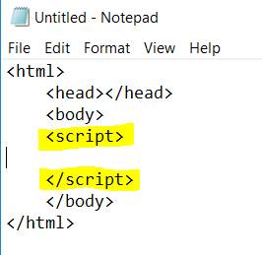

1. Now you need to add a couple of variables to hold the URL of the API we are going to connect to, and a request (to save us a lot of typing later):

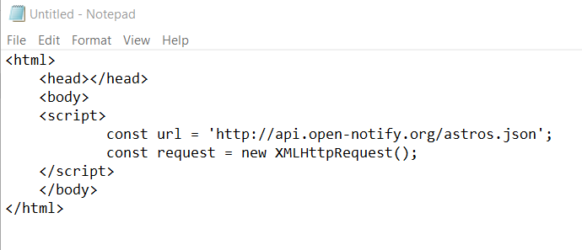

1. Now we’re going to add two lines to fetch the data from the API URL (or ‘endpoint’)

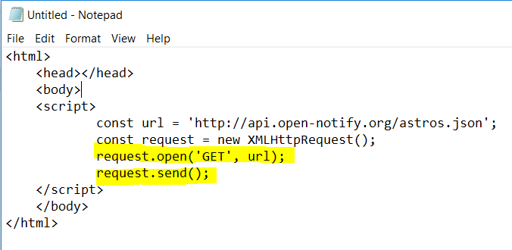

1. Now we need to create a script block in which we will put the instructions for the script, so itknows what to do with what it gets back:

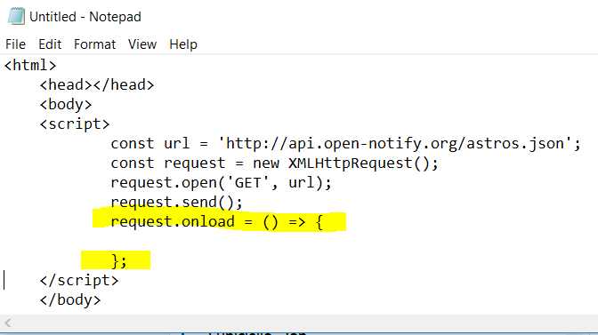

1. Now we need to add a block inside that one to make sure it only completes if the initial request was successful (ie, it returned a 200 code):

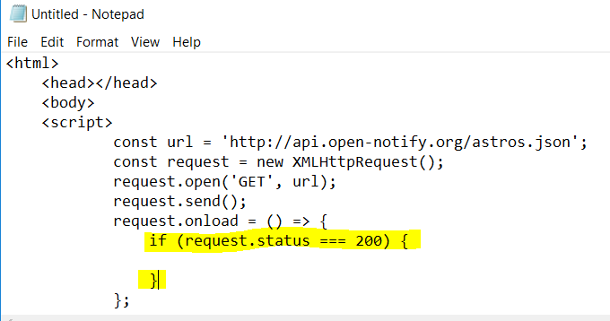

1. Now we’ll create a couple of variables to save typing and make things easier to read:

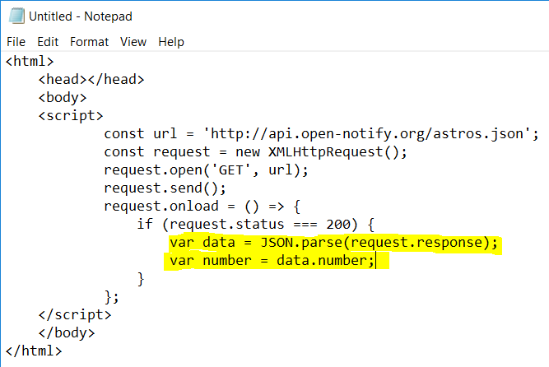

1. Now let’s write a line to display the number of people in the browser:

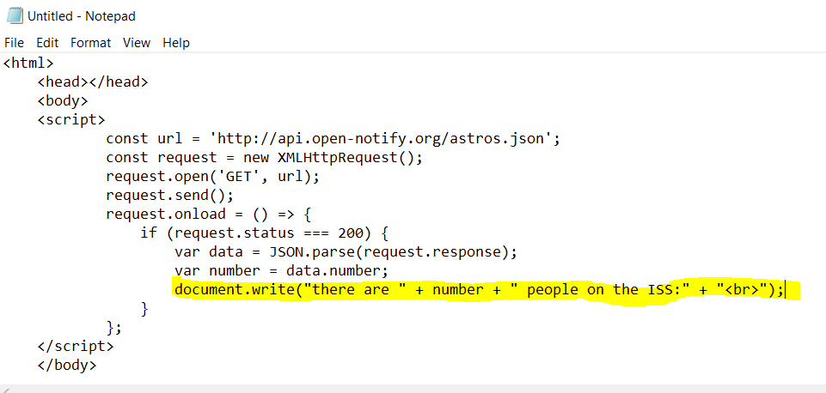

1. Now let’s add a loop to display all their names:

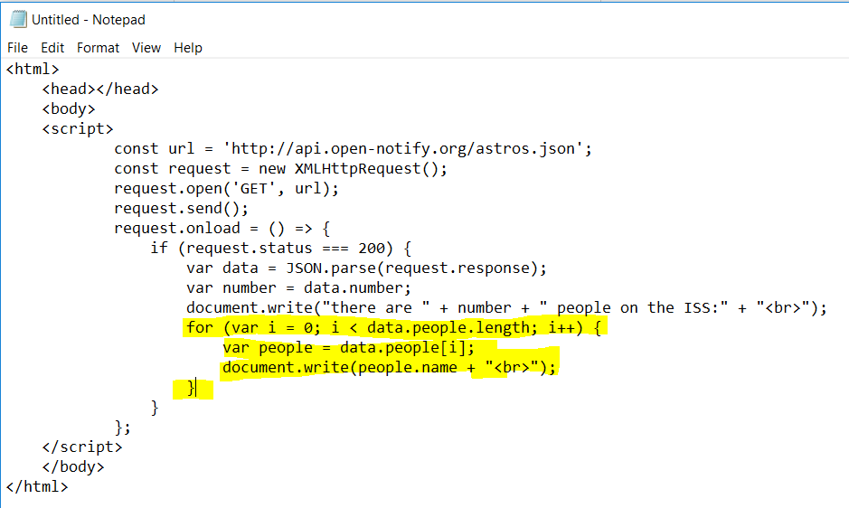

1. Save the file as index.html, and upload it the same way that you did earlier. You’ll need to tick the “overwrite” box

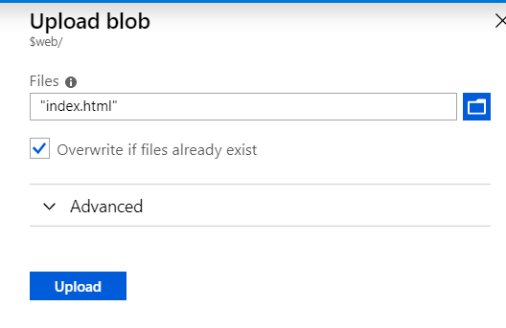

1. Browse to the URL you saved earlier in your web browser to see a list of the Astronauts on the ISS.
2. If you can’t be bothered doing all that typing, there is a file in the Franjilab repository you can copy – open the index.html file, click on raw, and copy and paste the content.